Soapbox Competition Application Form
Everyone wants to go back to the pre-Covid way of life
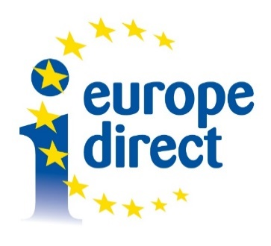
How to apply
Submit the form by email to your local Europe Direct Centre. Contact details are available at nenaghlibrary@tipperarycoco.ie
Competition closes Wednesday 18th November 2020 @ 5pm.

Application Form
Europe Direct Information Centre: _________________________________

Category: ☐ 18 & under ☐ 19 & over

Name: ______________________________________________________________

Age (if entering 18 & under category): ____________________________________

Address: ____________________________________________________________

Contact Telephone Number: ____________________________________________

Email: _______________________________________________________________

Applicant, please read and sign below:
I have read the rules regarding the soapbox events and agree to abide by them.

Signature of applicant: ________________________________________________
Date: ______________________________________________________________

Parent/ guardian, please read and sign below (for applicants under the age of 16):
Each EDIC will run an online event where the regional winning video entries are played. All regional winning video entries will then be played in a separate online national event on 9th December. Please sign below to consent to your child taking part in the competition and your child’s video entry being played during both of these events.

Parent/ guardian signature: _____________________________________

Date: _____________________________________________

